**Parking Management System using OpenCV**

**Priyanshu Singh1**

**Department of Information Technology, Chandigarh University, Gharuan, Mohali, India**

**18bet1057.it@gmail.com**

**Er. Divya K2**

**Assistant Professor, Computer Science &**

**Engineering, Chandigarh University,**

**Gharuan, Mohali, India**

**Divya.e12116@cumail.in**

*Abstract-:*

**This paper covers image development enhancements based on parking management. This project will work based on the ideas of the Background Removal algorithm. The use of this algorithm will be used as a map tool to reduce vehicle error. Now car parking is a big problem in a smart city. Due to the increase in traffic problems, the clever parking system operated using opencv provides an easy way out. Object Discovery has had a major impact about how the world has adapted to artificial intelligence in recent years. Other popular acquisition algorithms are area-based accumulative neural networks, one-time multiple-box detectors (SSDs), and Look Together (YOLO). Among these SSDs has better accuracy, while YOLO performance is better when it comes to speed provided with the selected accuracy. In-depth learning includes SSDs and Mobile Nets for easy access and use for tracking. This algorithm enables accurate detection while not compromising performance. All app functionality is based on the acquisition of an object in a particular location such as whether a rectangular space is completed or not. When found complete it means the site is empty and look for other options.**

**Keywords — Mobile Networks, COCO, Single Shot Detection.**

1. INTRODUCTION

After, Alex Net enters the research globe in year 2012 Image Net has a great deal of optical recognition, in order to achieve in-depth, far-reaching learning in the traditional viewing methods used in workbook. From a practical point of view, neural convolution networks are broken down into image segregation.

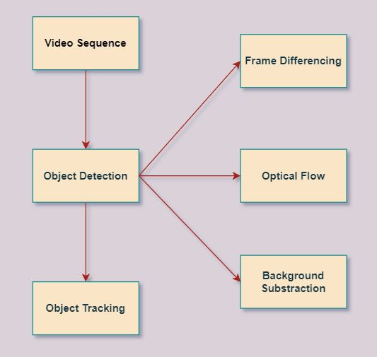

Fig. 1 Simple block diagram for object acquisition and Tracking

Figure 1 depicts a simple diagram of the discovery and tracing. In paper, algorithms based on SSDs and MobileNets are used to locate and track python location. Object discovery involves finding the object of interest of an object in a particular part of an image. Various methods of frame separation, light flow, background removal. This is a way to find something moving with the support of a camera.

Detection and tracing algorithms are use to defined by extracting images and videos features of security systems [3], [7], and, [8]. Features is released by applying CNN and in-depth reading [9]. Separators are apply for the image classification and, for the calculation [6]. The YOLO backed algorithm with the help of a GMM models using in-depth learning concepts will provide fine-grained output and, classification in [10]. Phase II describes Literature Review , Phase III the SSD and Mobile Nets algorithm, Phase IV describes the application process, and Phase V describes the simulation and, examination of result.

1. LITERATURE REVIEW

The methods listed from a very simple algorithm to the finally published method are classified by speed, memory requirements and accuracy. They have used methods: such as frame differences, real-time subtraction and shadow detection methods, as well as the appropriate background pattern method as a mapping. In real time. The algorithms they use range from the accuracy and complexity of different accuracy and calculation. Some of them can even solve real-time problems, such as snow, rain, moving branches, scattering, light energy or slow moving objects.  
  
Wei Lue, et al [1] This article presents SSD, a fast ONESHOT object detector for some types. A main feature of our model is the use of multiple complex selection outputs that are connected to multiple feature cards on the network. This performance allows effectively modeling boxes, shapes and white space. We have confirmed testing a default selection box more carefully with the appropriate learning strategy that leads to better performance.

Justin Lai, El AL [2] Detecting real-time objects used to improve the monitoring and providing promising applications of supportive nerve cells (CNN). A specific application is to detect pocket weapons like guns. Therefore, until now, previous work has focused only on detecting hidden weapons using infrared data.

Andrew G, el al [3] MobileEnenCTS is based on a sorted architecture that makes a light deep neural network using a deep extra discharge gas. We introduce two simple global hypermatters that are effectively exchanged with delay and accuracy. These hyperloors allow modeling models to select the right dimension model of the application according to the problem, so we present a wide range of experiments on resource and accuracy and demonstrate a powerful indicator compared to other popular models of the IMagenet and classification. It then shows the effects of mobile in a wide range of applications, including object detection, fanegrain classification, face attribute, and large-scale substrate analysis of information.

Akshay Mangawati, el al [4] This article provides a comprehensive overview of different object tracking algorithms under different environmental conditions and identifies efficient algorithms for different types of tracking. In this article, objects are tracked based on color and the movement of one or more objects (vehicles) is detected and counted over multiple frames. Additional integrated algorithms can be developed to track objects given their shape, color, texture, object of interest, and object movement in multiple directions.

Apporva Raghunandan, el al [5] Accurate and efficient object detection systems have been developed that achieve metrics comparable to state-of-the-art system health. This project uses the latest technologies in computer vision and deep learning.

X. Zhou, el al [6] In this, they propose a simple yet powerful pipeline that provides fast and accurate text detection in natural scenes. The pipeline directly predicts randomly oriented words or text strings and quads from complete images, eliminating unnecessary intermediate steps (such as candidate aggregation and word segmentation) with a single neural network. Because the pipeline is simple, you can focus on developing loss functions and neural network architectures.

R. K. Harahap, el al [7] In this article, they have successfully created and reviewed a parking space detection system. The results obtained make it easier to monitor parking spaces and increase the efficiency of parking systems, as well as identify and notify free parking spaces. Based on testing with video data in the form of a playback video stream, information can be presented in the form of text with information about available parking spaces. For further development, the Internet of Things (IoT) can be implemented.

S. Azabarika, el al [8] One of the important points in parking monitoring is to provide visitors with information about the number of vehicles in the parking lot. Several systems have been used, one of which uses an ultrasonic sensor. But often, visitors spend time looking for parking. They did not receive detailed information about the parking space.

B.Y Prabwo, el al [9] The server room is a room where data is stored and contains information about the company (DPC). Overheating of the server room can degrade device and network performance. Therefore, administrators must maintain the stability of the server space to maintain server and network performance.

Breglar, el al [10] The ease of a fully electronic world is now being tried in parking systems. Here, the parking system makes it easier for users to decide where to park, and this system makes it easier to develop and develop from parking reservations. and parking paying systems. Electric money management system. When creating this system, researchers rely on their own edge methods. This method makes calculations between the data already entered by the system and the new data it will collect in real time while the system is running.

Liang Wang, El AL [11] The extraction of the human body's function based on 2D image processing forms an effective method for some purposes. Measurement There are no elements of body size, build qualified models of people and recognition of human behavior. In this article, we propose a systematic approach to automatically detect the functional points of the human body of the front and side of the human body.  
  
Anderson, El AL [12] The document provides an effective markup line to recognize and the location of the target image. Meanwhile, high durable fuzzy control methods are designed to improve the stability and feasibility of robots checked in many cases. A suitable image system is designed according to the characteristics of the test environment and the results of the pre-processed result to get the image level image corrected.  
  
Hobette Singh, El AL [13] Certain systems are used to avoid common circulation problems in commercial areas consuming a lot of time, this document provides easy way to book parking systems . In this application, users can display different parking spaces and check the availability of positions.  
  
Shivayo, El Al [14] This project provides an intelligent parking system solution with IoT technology. The IoT application monitors the availability of parking space with real-time data stored in the cloud and users access this data via the Android application.  
  
Thanh Nam Pham1, el al [15] In this article, we propose a system to help users automatically find the cheapest free parking space based on a new performance measure to evaluate parking costs. of users by street and total number of spaces in each parking lot. This cost is used to suggest a solution to find available parking spaces at the request of the user and to suggest a new parking space if the existing parking is full.  
  
Elson baty, el al [16] With the growth rate, the parking lot increases with the number of car users. With the increasing use of smartphones and their applications, users appreciate mobile solutions. This item provides Smart Parking Management (SPMS) feature based on Arduino parts, Android app and Iodine. This allows customers to check available parking and reserve a parking space. Infrared sensors are used to find out if a parking space is allowed. Its regional data is transmitted by the WiFi module to the server and the mobile application is accessed, providing many attractive and free options for users and allows users to check details of the reading room . Using IoT technology, intelligent parking system can be wirelessly connected to easily monitor available locations.

Shrinivas Vishwanath, el al [17] Due to the increase in population in urban cities, the number of vehicles is increasing exponentially, leading to the main problems of poor traffic management and traffic congestion . Another major problem that vehicle owners face is the availability of parking spaces. The idea of ​​a smart city is slowly gaining traction with ever-changing technologies. Therefore, in the proposed parking system, we integrate the wireless sensor technology with the Android application so that the user can make a reservation or reserve a place. Vehicle owners can book their car from anywhere and will receive a QR code that will be scanned at the entrance to the parking lot. Another feature of our system is to provide information about nearby parking areas, which is useful when the current parking area is full.

Romi Ilham, el al [18] Parking system application is capable of converting manual processes into automated processes, facilitating management, finding the necessary vehicle data and providing records for vehicle entry and exit reports. to the management of. The implementation of this parking system took an average of 2.4 seconds to process the entry of vehicles, from PIN code scanning to license plate entry (Hermawati & Koesdijarto, 2010). During manual parking pass distribution, average time takes 1.5 seconds making faster, but keep in mind that manual process can be made faster only in terms of distributing cards, while in terms of user safety is still far from secure parking, and the convenience of staff and management is far away due to lack of reporting process and good service to management (Watene, Musiega, & Ndegwa, 2013). The system can be further improved by providing different options. In addition to online booking, GPS for empty parking by card, bill payment by various methods such as credit card, etc., and it can be installed in other operating system.

1. OBJECT SPOTTING AND TRACKING ALGORITHMS
2. *Single Shot Detector(SSD) algorithm*

SSD is a popular acquisition algorithm built on Google Incorporated. [1]. Based on the construction of VGG-16. Therefore, SSDs are simple and convenient to use.

It’s depict the dummy VGG 16 SSD. A set of the default fields is created to view the different functional maps as transformation methods. Points are awarded if the purchased item is one of the feature identifiers during prediction. The shape of the element is adjusted according to the position field. Each box predicts a change in attitude and confidence. During training, the automatic box is compared to the actual bottom box. All, Fully interconnected stacked layers are deleted in SSD format. The model loss is calculated as the average summation of confidence loss and, performance loss. The predictable variation of the predictive field from low reality field is a loss of local performance. Confidence is a measure of how dependent a system is on whether the predicted object is real.

Complete feature upgrades and installing all computers in one network using Single Shot Detection makes it simple to trained with Mobile Net. Collate to YOLO, the SSD is also faster in the way it makes clear regional proposals and integration (includes the Faster R-CNN).

1. *MobileNets algorithm*

Mobile Nets uses deep divisive synchronization that helps build stacked neural networks. The Mobile Nets models are best matched for mobile-based and embedded vision app where there is no process control. Mobile Net' main idea is to improve delays when building small emotional networks at same time. It focused at size only without focusing too much on speed. Mobile Nets is built on deep integration. In standard conversion, the input feature mapped is divided into many map features after conversion [2].

The total number of parameters in this model is greatly reduced by using deep separation convolutions compared to the fact that the network consists of standard convolutions of similar depth. Reducing the parameters results in a lightweight stacked network.

1. SYSTEM OF ACCOMPLISHMENT

The working of whole application is based on object detection and a CCTV camera mechanism. When a car enters in the premises the first step is to connect the car screen with the application and check whether any empty slot available if yes than it gives the location of all available location with green rectangle and rest with red rectangle in this way user can identify which location to go and where not.

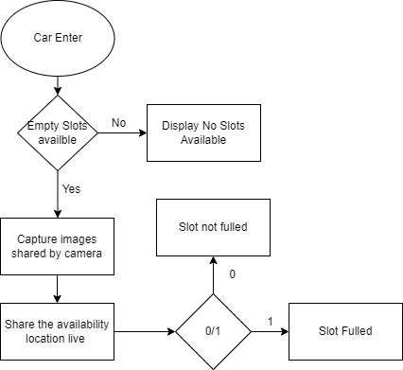

Fig. 2. Flow Chart of the application

In fig [2] when a car enters the first task is to check whether there is any slot available If “No” it simply return No slots available, If condition is “Yes” than it capture the image frame wise and pass through the certain algorithm which detect whether the slot is filled or empty. If found filled than represented by red rectangle and If green it means they are vacant and now there you can park your car. If any filled slot become available than the application automatically do it’s task and show vacant on screen through a green rectangle(0).

Object detection Framed isolation Frames are shot on camera from time to time. The difference is measured in consecutive frames. Flow of vision This process measures and to calculates the optical flow field with the algorithm which used for the optical flow. A local algorithm are used in validation of it. Sound filtering is done with an adaptive algorithm. It contains a broad overview of quantity and size of items and helps to avoid time-consuming and complex methods of preparation.

*Removing the Background*

Backgrounds (BS) are the fastest way to create moving objects from camera video. This generate the first step in a multi-level vision plan. Such, process simply split background from the front side of the image.

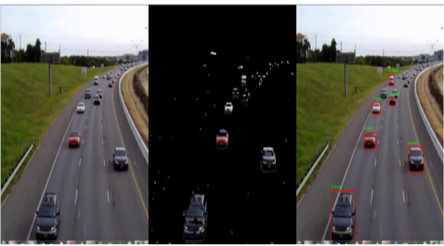

Fig. 3. Vehicle detection by background subtraction

Figure 3 Shows detection of vehicles in the rear range. The front or car is isolated from the back of the image for further processing. After intelligent display of the segmentation results, the effect of forming a breeding area occurs.

1. *Object tracking*

It is made with video sequences as security cameras and CCTV, surveillance feeds; the purpose is to track the process, the speed of the object. The real-time detection rate can be increased by using object tracking and the implementation of a few frames that are filmed over a set period of time. Acquisition of an item can work with slow-moving independent values for items you can lock and once those items are found and locked, tracking an item, can work at a faster frame rate.

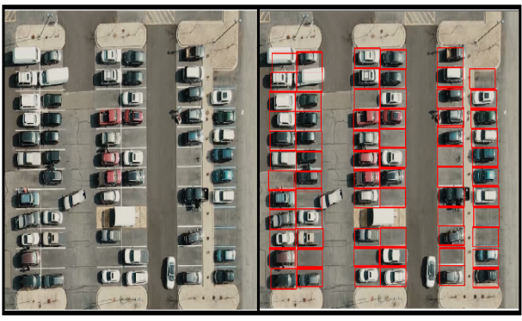

Fig. 4. Track of car

Fig. 4 Shows vehicle tracking. In the example above, there are two ways to track an item. (1) Follow the order received. It creates a continuous traffic video sequence from CCTV cameras. Let's say someone wants to track the movement of a car here. We will take different pictures at different times. With this picture you can see something like a car. If you then look at how my objects move to another video frame, you can calculate the object by checking the movement of the object in a red box that is imported from another location.

An improved method of "gaining power". In this way the balance of movement or movement of the vehicle occurs. By checking its location on a certain time period ‘t’ and measuring its location at the time of let’s say add(10,t). via this realistic picture of a car during the add(10,t) it can be done with the help of scales.

1. SIMULATION OUTCOME AND ANALYSIS

These outcomes are observed after the successful scanning, detection and, tracking of video which is feed by the video sequences camera.

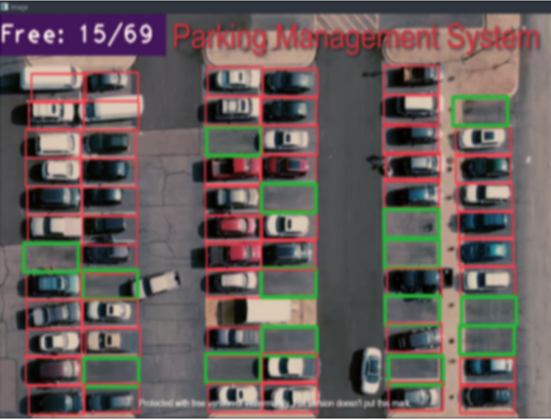

Fig. 5. Vehicles Detection

Fig. 5 show real-time detection of vehicles respectively. The model is trained to get 69 parking location out of which 51 are filled for now and left with 15 free spaces. The green rectangle represent the vacant places and red use spaces.

1. CONCLUSION

In real-time scenarios, we use the SSD algorithm to get the items. In addition, SSDs give results with high reliability. The main purpose of SSD algorithm is to use to detect various objects such as in real-time video footage and load them into real-time live data. This model has demonstrated a positive effect of detection and tracking in professional settings, and may have been used in some cases by us for targeted video-based detection, tracking and response. target at the front desk. This real-time ecosystem scan can yield positive results by improving the security, order, and friendliness of any business. In the event of a terrorist incident, we are constantly strengthening our search for ammunition and ammunition magazines to trigger the alarm. This model can also be used with CCTV systems, drones and other surveillance devices to monitor in many difficult to manage parking areas, such as schools, offices government and, hospitals. This application simplifies your work by making task management fully automated. All functions, such as connection to the vehicle display and real-time data exchange with the driver, make parking management less efficient.

1. REFERENCES
2. WeiLiu and AlexanderC. Berg, “SSD: Single Shot MultiBox Detector”, Google Inc., Dec 2016.
3. JustinLai, Sydney Maples, "Gun Discovery: Improving the Real-Time Gun Discovery Class", Stanford University, Feb 2017
4. AndrewG. Howard, and Hartwig Adam, “MobileNets: Efficient Convolutional Neural Networks for Mobile Vision Applications”, Google Inc., 17 Apr 2017.
5. Akshay Mangawati, Mohana, Mohammed Leesan, H. V.. 0676-0680.
6. Apoorva Raghunandan, Mohana, Pakala Raghav and H. V. Ravish Aradhya, “Video Acquisition Algorithms” International Conference on Communication and Signal Processing (ICCSP), India, 2018, pp. 0570-0575.
7. X. Zhou, C. Yao, H. Wen, Y. S. Zhou Wang, W. He, et al., "East: an effective and accurate scene text detector", Procedures for IEEE Computer Computer Vision and Pattern Recognition Procedures, pages 5551-5560, 2017.
8. R. K. Harahap no-E. P. Wibowo, "Model ic design lesson for improving the use of the higher education system (hep)", 2019 International Conference on Informatics and Computing (ICIC), pages 1-5, 2019.
9. D. S. Azkarika, Monitoring online ketersediaan slot parkir berbasis camera via menggunakan jingle pi, vol. 3, 2017.
10. B. Y. Prabwo, Deteksi tempt parkr berbasis raspberry pi detection, 2018.
11. C. Bregler. Learning and seeing human potential through video sequencing. Procedures for IEEE CS Conference on Computer Vision and Pattern Recognition, 1997, 568-574.
12. Liang Wang, Hu and Tan. Recent advances in human behavior analysis. Pattern Recognition Journal, Elsevier publication, 2003, 585-601.
13. C. Anderson P. Bert, G. Vender Wal. Change detection and tracking using pyramid conversion techniques. Performance of SPIE-Intelligent and Computer Vision robots. Vol. 579, 1985, 72-78.
14. Harmeet Singh, Chetan Anand, Vinay Kumar, Ankit Sharma, “Automated Parking System With Bluetooth Access”, International Journal Of Engineering And Computer Science ISSN: 2319-7242, Volume 3 Issue 5, May 2014, Page No. 5773- 5775.
15. C. Shiyao, W. Ming, L. Chen, and R. And, `` Researching and implementing a ZigBee parking lottery management system based on ZigBee technology, '' Proc. 6th Int. Conf. Meas. Technology. Mechatronics Autom. (ICMTMA), 2014, pages 741_744
16. Thanh Nam Pham1, Ming-Fong Tsai1, Duc Binh Nguyen1, Chyi-Ren Dow1, and Der-Jiunn Deng2 “A Cloud-Based Smart-Parking System for Internet of Things Technologies”, IEEE Access , Retrieved July 24, 2015, adopted August 16, 2015, publication date September 9, 2015, current translation date 23 September 2015.
17. Elson baty, Amira A. Smart Parking Management Systems (2020). International Journal of Computer Science and Information Technology (IJCSIT), Volume 12, Issue 4, August 2020.
18. [Srinivas Vishwanath](https://ieeexplore.ieee.org/author/37088639016), Vehicle Parking Management System [2020 International Conference on Convergence to Digital World - Quo Vadis (ICCDW)](https://ieeexplore.ieee.org/xpl/conhome/9318602/proceeding)
19. Romi Ilham, PARKING MANAGEMENT INFORMATION SYSTEM BASED ON ANDROID, September, 2018 INTERNATIONAL JOURNAL OF RESEARCH SCIENCE & MANAGEMENT